**“Home” page**

About us:

With a career in Accounting, Audit, Tax and Corporate Finance spanning a period of over 20 years, I now run my own audit and tax consultancy firm which offers me the opportunity to utilize my professional financial expertise, extensive business experience, and ability to interact with clients and the business community (in general) at an international level.

Our consultancy firm’s working attitude can best be described with the following keywords: a direct approach, a lot of attention towards client’s requirements, a strong vision, strong analytical insight, clear communication, a lot of knowledge and working experience (with a desire to share these), and creativity.

We are the fore front of technical updates and industry know-how to ensure that our services reflect current developments in the fields of international financial reporting, tax laws and auditing standards.

**(Download firm profile)**

Professional Achievements:

* Masters of Science Degree in Professional Accountancy from University of London, UK.
* Bachelor of Science (Honours) degree from the Oxford Brookes University, United Kingdom BSc (Hons) in Applied Accounting. Class of Degree: FIRST CLASS HONOURS WITH DISTINCTION.
* Fellow Member and Chartered Certified Accountant from the Association of Chartered Certified Accountants, United Kingdom (FCCA, UK).
* Certified Public Accountant from the National Board of Accountants and Auditors (NBAA). I am a holder of certificate of practice from NBAA.
* Chartered Professional Accountant and Certified General Accountant from CPA Canada, British Columbia.
* Tanzania Revenue Authority (TRA) registered tax consultant.
* Certified Internal Auditor (CIA®) from the Institute of Internal Auditors.
* UAE Chartered Accountant
* Member of the Tanzania Association of Tax Consultants (TATC)

**“Our Team” page**

(as is)

**“Our Services” page**

Sub pages:

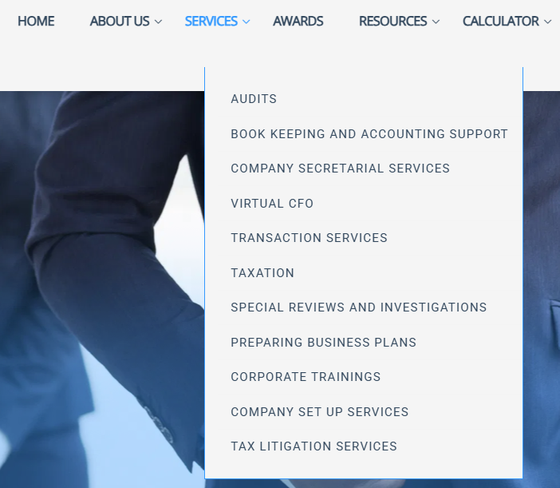

**Audits**

We offer fraud investigation, forensic, internal and external audit services.

Our audit team comprises of qualified and experienced auditors who are accustomed to providing local expertise with an international taste.

Audits are an independent, objective evaluation of an organization’s financial and non-financial reports, financial reporting processes and systems of internal control. We offer external audit services to companies to ensure that their financial statements give a true and fair view of their financial performance and state of affairs as at year end.

We also provide assurances on the company’s internal control processes and organizational systems.

In line with the Companies Act 2002, every limited liability company in Tanzania is mandated to have its financial statements audited and submitted with Business Registration and Licensing Agency (BRELA) along with annual returns (BRELA Form 128).

In line with the Income Tax Act, every taxpayer in Tanzania is mandated to have its financial statements certified and submitted with Tanzania Revenue Authority along with final tax returns within 6 months following year end.

We also provide internal audit services. We have a Certified Internal Auditor (CIA®) in our team.

We also take pride in offering fraud investigation and forensic audit services. We have certified fraud examiners and investigators in our team.

We use computer-aided auditing techniques in providing these services.

**Book Keeping and Accounting Support**

Spending too much time to prepare your books of accounts?

Our accounting support team provides assistance to businesses across the country and globe to maintain their daily business transactions in a systematic manner by preparing books of accounts and producing financial reports which are IFRS/IFRS for SMEs compliant.

We are conversant with diverse accounting software; such as: Sage Pastel, MYOB, Quickbooks, Tally ERP and Tally Prime.

We can assist you with maintaining your books of accounts fully (total outsourcing), or partly by supervising in-house book keepers and accountants and reviewing their work on regular basis.

We also provide be-spoke advises and guidance on design of chart of accounts and accounting system set up.

**Company Secretarial Services and Registration of Trade & Service Marks**

Companies in Tanzania are required to make all necessary filings with the Business Registration and Licensing Agency (BRELA). This includes but is not limited to the filing of annual returns, appointments and termination of directors and company secretaries, increase or decrease in share capital, and UBO declarations.

Our office is best placed to assist you with these required filings at BRELA.

We also provide assistance to register Trade & Service Marks that will provide a platform for your designated brand to achieve higher quality goods/services in the market. It will also protect your entity name and /or logo and or product name from being copied by others thereby preventing unfair competition. You will boost customer/client confidence because they now know that they are dealing with a recognized and well-established brand. It will create potential source for franchise opportunities and recognition of in house/organic high net worth intangible asset.

We also provide company formation services to investors and start ups.

Our services are not limited to companies. We also provide similar services for sole proprietorships, partnerships, branches, trusts, societies, and NGOs.

**Virtual CFO**

We believe that a CFO (Chief Finance Officer) is the heartbeat of any successful organization. Successful CFOs partner with business owners and other managers in making critical decisions which directly impact the success of your business.

*Why Do I Need a Virtual CFO?*

Since most entrepreneurs have to labour long and hard to get their companies where they want to be, they have to wear a number of different hats. If you are an entrepreneur, you have certainly felt, at some point, as if you’re doing everything by yourself!

In such a case, you need a strategic partner for managing and reviewing accounts, preparing annual budgets, tax planning and much more. In short, you need someone who can complement your finance & accounting team and manage your expanding ventures. At the same time, you can’t afford a CFO who demands a fat salary!

Recruiting this heartbeat is not an easy task and comes with a huge cost to company. Not every business can afford this bill.

Whether you need a seasoned leader to provide advisory or interim CFO services or support for critical projects, we can provide the leadership, action and results to meet your needs.

For this very reason, we at Hanif Habib & Cco. provide Virtual CFO services. We bring in the right amount of experience in managing accounts and team, hiring, planning and strategy, performance evaluation and most important give professional face to the organisation. We are not full-time employees of your company, but will always be available for consultation and implementation.

Depending on your needs, we can offer a flexible model for engagement as Virtual CFO, and help take your company to ever-greater heights.

*What comes with our CFO services?*

* High level review of your financial reports, statements and budgets
* Strategic idea formulation
* 24/7 availability in terms of financial discussion and problem solving
* Representing the company in high level meetings with potential investors, bankers, lenders;
* Advanced financial planning and analysis;
* Selective internal audits
* Optimum tax advises
* Reviewing and re-designing systems of internal control within the organization to prevent frauds and errors
* Organization re-structuring advise – when necessary
* Corporate finance advises – debt v/s equity injection when financing needs arise
* Interaction with company external auditors and regulators

**Transaction Services**

With our dedicated specialists in our Global Transaction Services Business, we can bring you, our client, a combination of financial, commercial and operational insight to every deal. We deliver unparalleled knowledge as we navigate the deal process with you.

Whether you are making an acquisition, divestiture, or strategic alliance, in each case we have the same objective – to make sure you get the maximum return on your deal.

We combine our financial, commercial and operational expertise with data-driven insights to help you create value across all stages of the deal lifecycle.

We also offer payroll outsourcing services which primarily includes maintaining company payroll and salary packing services for high-level executive personnel and expatriate staff.

**Taxation**

Our tax services are designed to help clients to tap into today’s competitive business as well as fiscal environment through effective tax planning and maximization of tax incentives while maintaining regulatory compliance. We offer a whole range of superior tax services in line with the government’s self-assessment system.

We have a team of experienced professionals dedicated to strive to assist our clients in the area of tax compliance. We can deliver the right level of tax support that you need to achieve your goals – from tax consulting to help you document your corporate tax strategy to fully outsourced tax compliance services.

We also specialize in preparation of Transfer Pricing Documentations.

Our tax professionals draw on deep experience and industry-specific knowledge to deliver clients the insights and innovation they need to maintain compliance.

We can act as your appointed tax consultants and handling all matters of taxation on your behalf with Tanzania Revenue Authority.

We can also assist with preparing and filing of:

*• Monthly Value Added Tax returns;*

*• Monthly Withholding Tax payments and returns;*

*• Monthly Skills and Development Levy returns;*

*• Monthly Excise Duty and Bed Night Levy returns;*

*• Monthly NSSF and WCF returns;*

*• Quarterly Provisional Tax returns;*

*• Quarterly City Service Levy returns; and*

*• Yearly Final Tax returns;*  
**Special Reviews and Investigations**

This includes tax health checks, accounting health checks, compliance reviews, agreed-upon procedures to perform a finance relate task or assignment and special audits. Each business is unique and may require some form of regular independent checks to ensure proper compliance with laws and regulations of the land, up-to-date financial reporting system, closure of any loop-holes in systems of internal control and detect frauds and misstatements.

We can be your trusted financial advisors for this.

**Preparing Business Plans**

We prepare business plan with business goals, the methods on how these goals can be attained, and the time frame within which these goals need to be achieved.

Our business plans also describe the nature of the business, background information on the organization, the organization’s financial projections, and the strategies it intends to implement to achieve the stated targets. Such business plans are known to be robust and stand good chances for securing funding from potential investors and lenders.

We believe that your business success is our success. We hope you will allow us to become a partner to your business.

We provide a road map that provides direction to the business.

**Corporate Trainings**

Our company offers a series of in-house training and public seminars and coaching services that support individuals and organizations in maintaining and increasing their energy, focus and vision. When we are clear and focused our personal and professional effectiveness increases.

Our company offers a series of in-house training for corporate in order to enhance organizational capability in financial reporting, compliance, taxation and internal audit.

Our certified trainers specialize in IFRS, IFRS for SMEs, IPSASs, Tanzanian Tax laws and regulations, and internal audit trainings.

We assist in bridging competency gap towards building a skilled and productive workforce to meet the challenges of global business competitions by corporates.

**Business Set Up Services.**

We can help you to set up a lawful and well-established presence of your business in Tanzania.

We provide the following services:

* Incorporating an entity with BRELA (Limited Liability Company, Partnership, Sole Proprietorship, Branch)
* Registering your business with Tanzania Revenue Authority and getting Taxpayer Identification Number (TIN) and Value Added Tax Registration Number (VRN)
* Obtaining Business Licenses
* Obtaining necessary regulatory licenses, approvals and clearances (including tax clearance certificate)
* Assistance on acquisition of relevant EFD/ESD machine (that suits your accounting system) and necessary support for EFD compliance purposes.
* Assistance for getting office space – be it physical or virtual
* Assistance with setting up website and email domains including web, logo and CI designing services
* Registering your business with NSSF, WCF, OSHA, PDPC, and other regulatory bodies in Tanzania
* Setting up organizational structure and drafting employment contracts
* Recruitment and selection services (restricted to Internal Audit and Finance Department)
* Assistance with opening of business bank accounts in Tanzania
* Any other help that you may require to do business in Tanzania

**Tax Litigation Services**

A difference in tax opinion between taxpayers and Tanzania Revenue Authority during routine tax audits (over whether and how much the taxpayer is obliged to pay) is very usual and common.

These unresolved differences don’t stop Tanzania Revenue Authority from issuing tax assessments.

When you face such questionable assessments, we can assist you with:

* Independent review on whether the assessment was issued fairly or not based on our fact-finding techniques and legal interpretations related to the tax in question
* Providing consulting services regarding the procedures, costs, and chances of winning if you decide to proceed with the tax objection, appeals and litigation; and
* If desired, we can also offer total support by handling the tax objection, appeals and tax litigation on your behalf at the Tax Revenue Appeals Board.

Steps in the Tax Appeal and Tax Litigation Process:

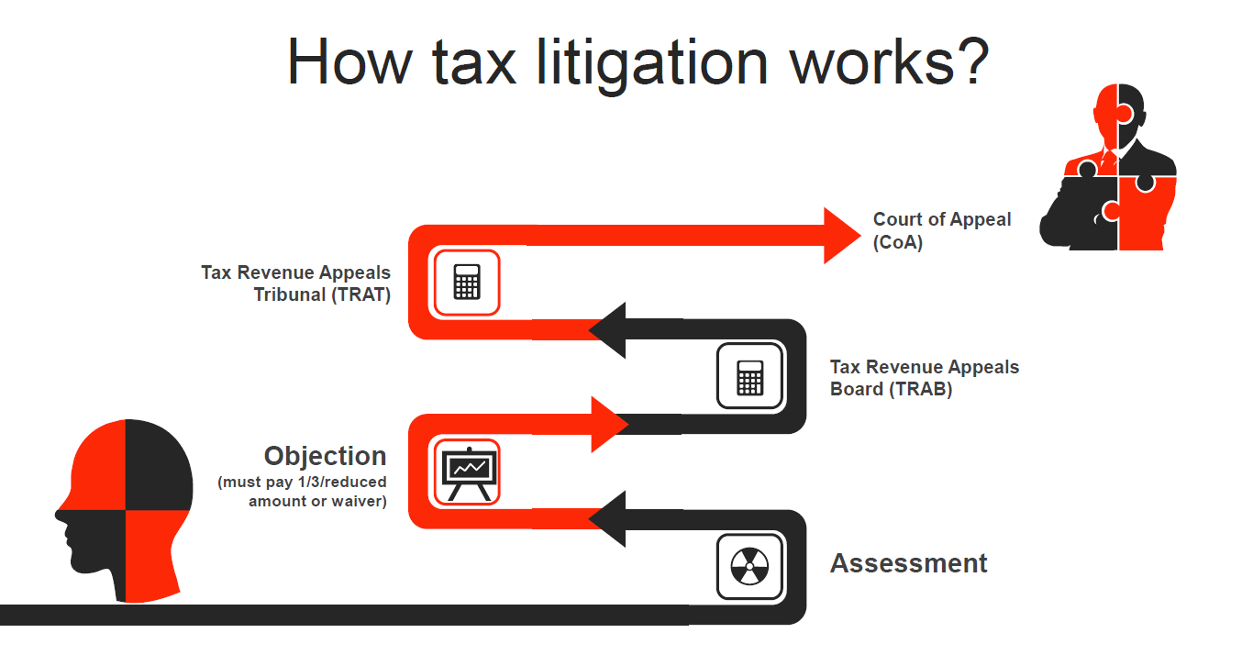

(re-create/re-design this image)

**“Awards” page**

(same)

Experience:

* Mining – Mineral and Gas Exploration.
* Fast Moving Consumer Goods (FMCG) Manufacturing.
* Schools and Educational Institutions.
* Law Firms.
* Trading Organizations (Retail and Wholesale).
* Heavy Commercial Vehicles Importers.
* Leasing Industry.
* Micro Finance Companies.
* Real Estate.
* Vehicle Renting and Leasing Companies.
* Advertising and Marketing Companies.
* Import and Export Oriented Companies.
* Human Resource Management Firms.
* Insurance Broking.
* Energy and Utilities.
* Other Professional Services Firms.
* Family Owned and Small Businesses.
* Transport and Travel.
* Hospitality and Tourism.
* Non-Banking Financial Institutions.
* Commercial Banks.
* International Quality Assurance and Standardization Service Companies.

**“Resources” page**

(same)

**“Tax Calculators” page**

(same)

**“Contact Us” page**

(same)